AWS notes

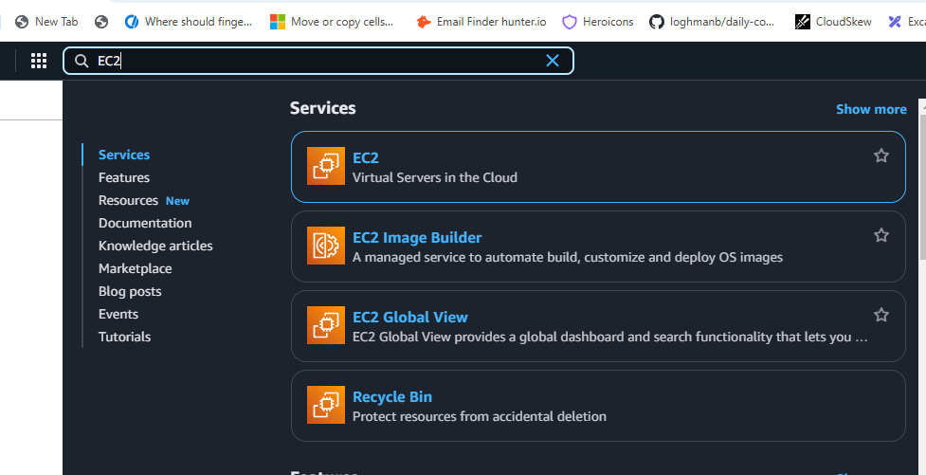

Type EC2 in search bar

Click on EC2 then click Launch Instance  
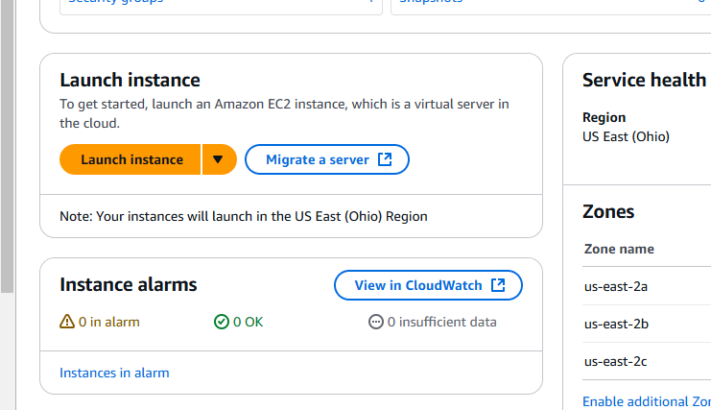

Then enter name “devops-linux”

Amazon Linux

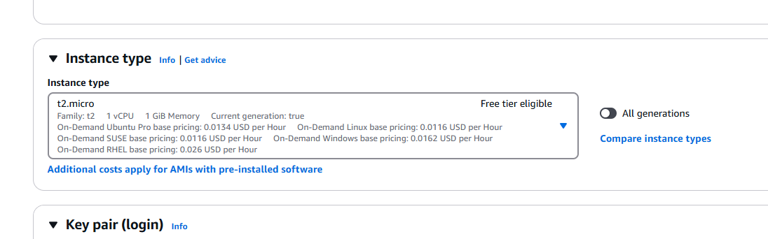

t2.micro

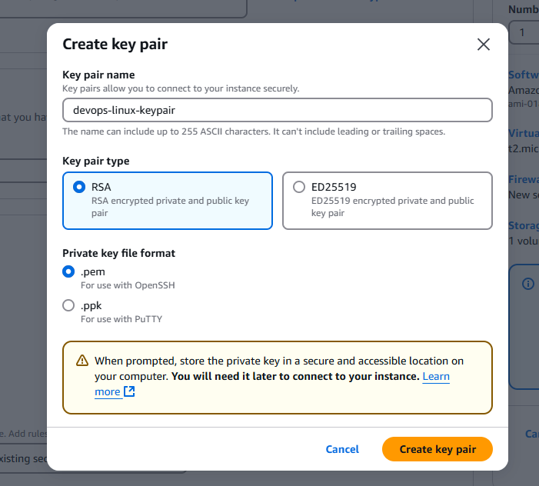

Click Create Key pair it will download

Rest of all no changes

Click Launch Instance

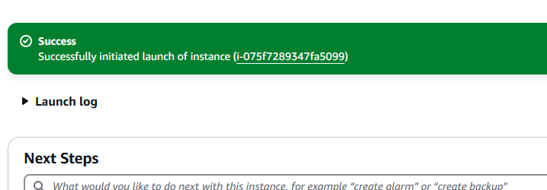

Successfully created instance

Click on that instance link

Linux Devops instance running

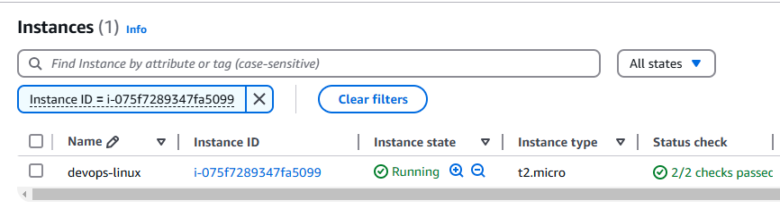

Click on Instance ID

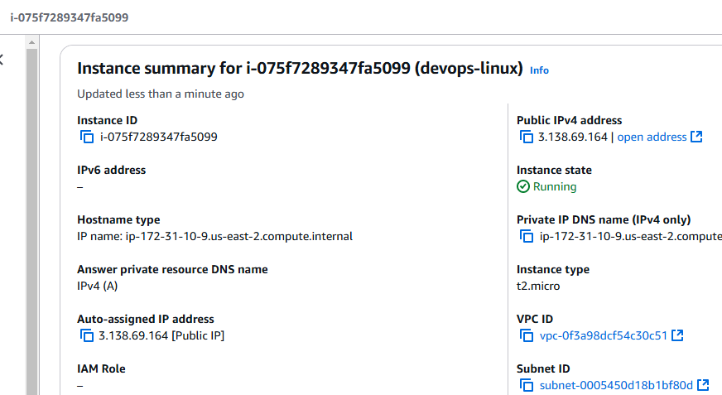

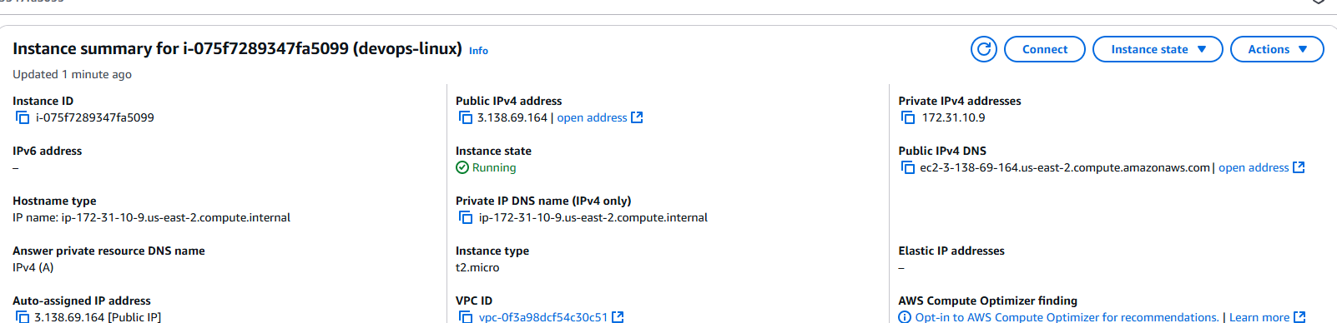

Click on Connect button

Click on SSH Client

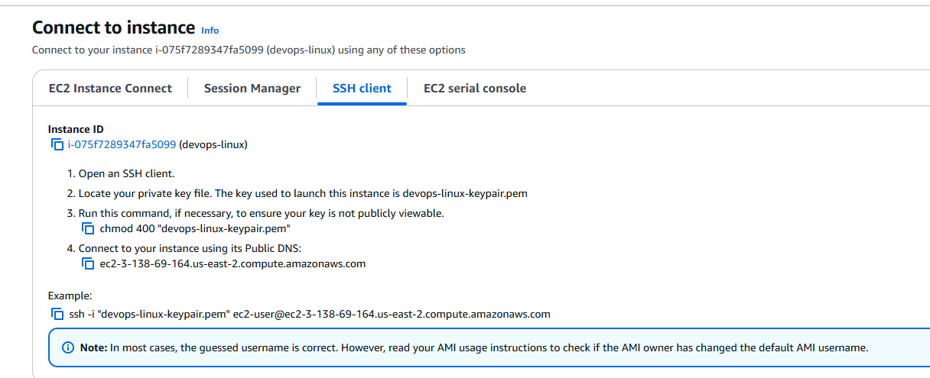

Then download MobaXterm Portable

Open MobaXterm -> top left -> SSH

Go to EC2 page -> Click on EC2 Instance Connect -> Copy Public IP

In MobaXterm, -> click Advanced SSH settings -> Use private key -> Select the .pem key downloaded

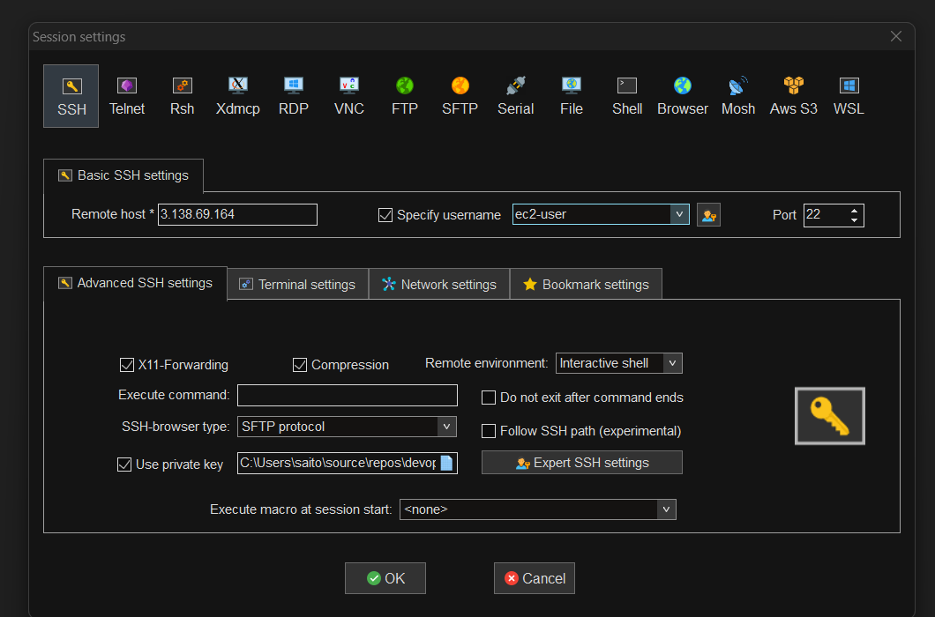

Click OK

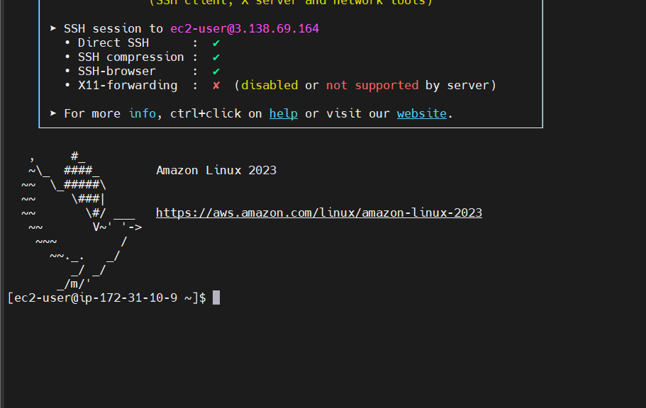

Type Linux comands :

whoami, date, cal

Linux file system:

Pwd, cd .. to go back one level